The file named “numdata.txt” contains a list of type double numbers. Write a C++ program to open the file and read the data into a 1D array. Write the program so that the program determines the number of elements that are required for the array. Use the data in the array to create two output data files. One with a sorted list of numbers from smallest value to largest value. The second output data file shall be a histogram table with the following form.

Bin Number of Values
0-10 $0≤value<10$
10-20 1$0≤value<20$
20-30 $20≤value<30$
30-40 $30≤value<40$
40-50 $40≤value<50$
50-60 $50≤value<60$
60-70 $60≤value<70$
70-80 $70≤value<80$
80-90 $80≤value<90$
90-100 $90≤value<100$

Document the program with:

A. A brief description of the purpose of the program and the structure of the program.
This program reads a list of double-precision numbers from a file and stores them in a one-dimensional array. It then sorts the numbers in ascending order and writes the sorted list to an output file. The program also creates a histogram table that groups the numbers into bins based on their value ranges (e.g., 0–10, 10–20, etc.). The structure uses a vector for dynamic data storage, file streams for input and output, and basic loops for data processing.
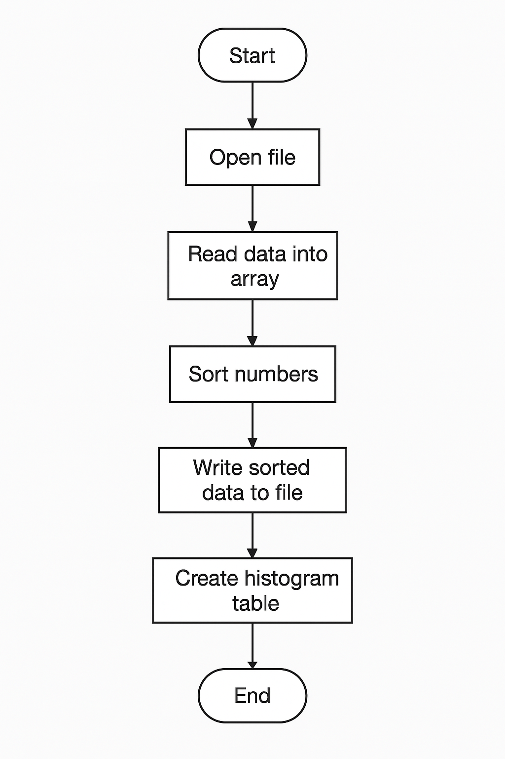
B. A flowchart to describe the structure of the program.

C. The code listing.

// ECE 2305 - Programming Project 07

#include <iostream>
#include <fstream>
#include <vector>
#include <algorithm>
#include <iomanip>

using namespace std;

int main() {
ifstream in("C:\\Users\\anmal\\Desktop\\ECE 2305 - C++\\numdata.txt");
vector<double> nums;
double x;
while (in >> x) nums.push_back(x);
in.close();

sort(nums.begin(), nums.end());
ofstream sorted("sorted_data.txt");
for (double n : nums) sorted << fixed << setprecision(4) << n << "\n";
sorted.close();

int bins[10] = {};
for (double n : nums) if (n >= 0 && n < 100) bins[int(n / 10)]++;

ofstream hist("histogram_table.txt");
hist << "Bin\t\tNumber of Values\n";
for (int i = 0; i < 10; i++) hist << i * 10 << "-" << (i + 1) * 10 << "\t\t" << bins[i] << "\n";
hist.close();

cout << "Done.\n";
system("pause");
return 0;
}

D. Two output .txt data files.
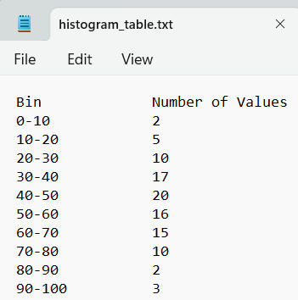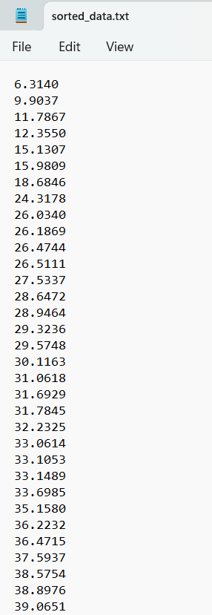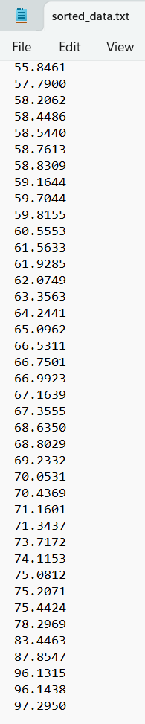

Upload the PDF and the TXT files to blackboard.

